How Do We Improve Our MR Signal?

Multi-Pulse Sequences and Spin Echoes

Table of Contents

*Expected Learning Outcomes* 2

Background Information 3

Classwide Discussion 4

Observation Experiments: Spin Echoes 4

Guided Inquiry Questions 4

Hahn Echo Theory 6

Guided Inquiry Questions 7

Can We Find Using a Single Experiment and More Pulses? 7

Guided Inquiry Questions 8

Reflection Questions 8

Supplemental Reading 11

Cited Sources 11

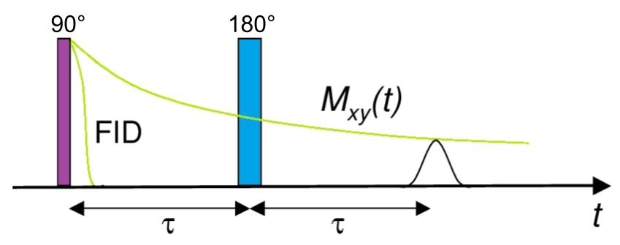

***Example Real-World Application*** Pulsed NMR is the most common approach to doing modern-day NMR. The NMR technique developed by Purcell and Bloch in 1946 used *continuous wave* NMR where electromagnetic radiation was continuously applied to the sample and then the frequency was steadily changed to build up frequency absorption spectra. Pulsed NMR was developed in 1950 and made use of short-duration electromagnetic pulses to excite a wide range of nuclei all at once. The acquired free induction decay signal is ideal for Fourier analysis to quickly visualize the different resonant frequencies present. Over time, more advanced NMR pulse sequences were developed that enable techniques like signal enhancement, separating out different forms of NMR interactions contributing to the signal, multidimensional NMR spectroscopy, and MR imaging.

## *Expected Learning Outcomes*

*At the end of this module, students should be able to…*

1. *Use Bloch simulator and a physical model to answer questions about the spin dynamics resulting from a given pulse sequence (*[*Scientific Ability A4*](https://sites.google.com/site/scientificabilities/rubrics)*)*
2. *Extract information from provided NMR experimental data (*[*Scientific Ability A1*](https://sites.google.com/site/scientificabilities/rubrics)*)*
3. *Choose correct experimental parameters to optimize contrast for different samples. (*[*Scientific Ability A4*](https://sites.google.com/site/scientificabilities/rubrics)*)*

**“There is nothing that nuclear spins will not do for you, as long as you treat them as human beings.”**

— Erwin Hahn, quoted by a colleague (1)

# Background Information

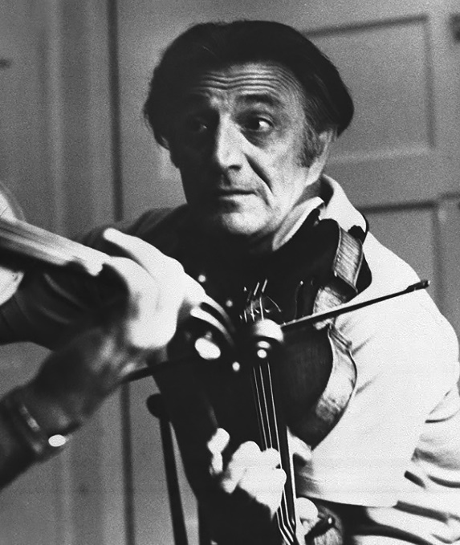**Erwin L. Hahn** - often referred to as the "Wizard of Magnetic Resonance" for developing the use of pulsed NMR and his 'accidental discovery' of the spin echo. Along with his many scientific contributions, Hahn was well-known for his humor and talents as a musician and entertainer (1).

"Good morning! I feel a bit like a mosquito at a beach…" and indicated the numerous props to the startled audience. "I don't know where to start!”  
- Erwin Hahn, when presenting a physics of music lecture

Photo used with permission from the family of Erwin Hahn.

In order to determine the relaxation time in the previous module, your experiment most likely involved multiple pulses. In fact, very soon after coming up with using an electromagnetic pulse and measuring the free induction decay, Erwin Hahn discovered a fascinating phenomenon when he looked at the NMR signal after multiple pulses. Hahn was fond of telling the story of his ‘accidental discovery’ which occurred when he was a post doc at the University of Illinois, Urbana. Similar to the application experiment in the previous module, Hahn was measuring nuclear relaxation times when he applied two pulses separated by a time interval instead of one. Along with the expected FID signal after each 90 pulse, he saw a puzzling ‘ghost’ signal following the second pulse that he initially thought must have been the result of a glitch. Hahn’s later realization of the cause of this puzzling signal - which he termed a ‘spin echo’ (2) - ultimately led to the development of multiple pulse sequences that enable a diverse amount of modern-day MR techniques.

In this module, you will undergo your own explorations of spin echoes making use of visualizing the spin dynamics on the Bloch sphere and looking at the results of various NMR experiments. Let’s begin with a review of interpreting pulse sequence diagrams by analyzing the pulse sequence shown below.

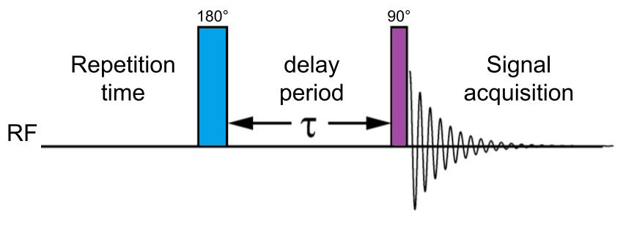

## Classwide Discussion

* What state is the net nuclear magnetization vector in at the end of the relaxation delay period? Right after the inversion (, i.e. 180) pulse? At the end of the delay period ()? Right after the second (i.e. 90) pulse?
* This is called an **inversion recovery pulse sequence**. Why do you think it is called that? What relaxation time might this experiment be helpful to measure?

# Observation Experiments: Spin Echoes

Let’s return, one more time, to the [Bloch Simulator](https://www.drcmr.dk/BlochSimulator/) to see if we can generate our own spin echoes and make sense of how the MR signal can potentially be coming back.

Set up the Bloch simulator to use ‘Inhomogeneity’(an option in the ‘Equilibrium’ menu) so that we will see multiple spins responding to an inhomogeneous external magnetic field. We can leave relaxation off for now to make any echo appear more obvious. Let’s hop into the rotating frame (set frame to ‘B0’) to help clarify what we see.

## Guided Inquiry Questions

1. After setting up the simulator as described above, knock down the spins with a hard- pulse and draw a sketch and write a description of what you see. Add some arrows to your sketch showing which spins are precessing clockwise and which are precessing counterclockwise in the rotating frame. Recalling how we set up the simulation, what is causing the spins to dephase from each other? What relaxation time would characterize the resulting MR signal decay?
2. 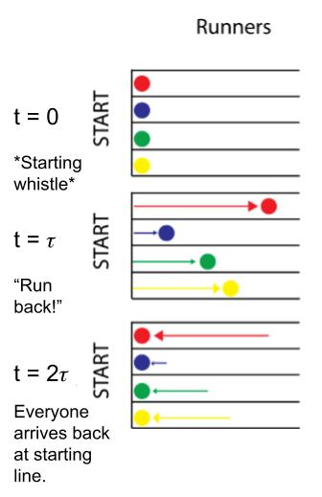Start the spins at equilibrium again (by clicking on ‘Inhomogeneity’), knock down the spins with a hard- pulse, and after some time, apply a pulse. Draw a sketch and write a description of what you see after the pulse is applied. Keep track of the the direction of the spins precession in the rotating frame before and after the pulse. Does the direction of the each individual spin’s precession change with the pulse? Does this make sense considering the direction of the external magnetic field has not changed?
3. It is helpful to have a physical model in your head to make sense of the spin dynamics on the Bloch sphere that lead to spin echoes - some favorites are racers on a race track or opening/closing a folding fan. Choose your favorite physical model and explain what causes the echo you observe, in your own words.

One possible physical analogy for the Hahn spin echo, consider runners on a race track that are told in the middle of the race to turn around and run back towards the starting line. Even if they run at different (constant) speeds, they will all return to the starting line at the same time.

Another possible physical analogy for the Hahn spin echo is the opening, rotation, and closing of the fan to represent the dephasing and then rephasing spins in the xy plane of the Bloch sphere.

*FUN FACT!* You can get spin echoes with any two pulses, but different spins can refocus at different times. The traditional Hahn echo pulse sequence ( pulse followed by pulse) optimizes the echo so that all spins precessing at slightly different frequencies refocus at the same time. You can read more at the following link, which includes an explanation of what Hahn referred to as the "eight-ball echo": <https://www.mriquestions.com/90deg-90deg-hahn-echo.html>.

1. Does the phase of the pulses (that is, whether they are applied in the x- or y-direction) appear to determine whether you see an echo or not? Apply different combinations of pulses on the simulator and your physical model to settle on your answer.
2. If the time between the and pulses is , how long after the pulse do you expect to see the peak of the echo? Use the simulator and your physical model to settle on your answer.

# Hahn Echo Theory

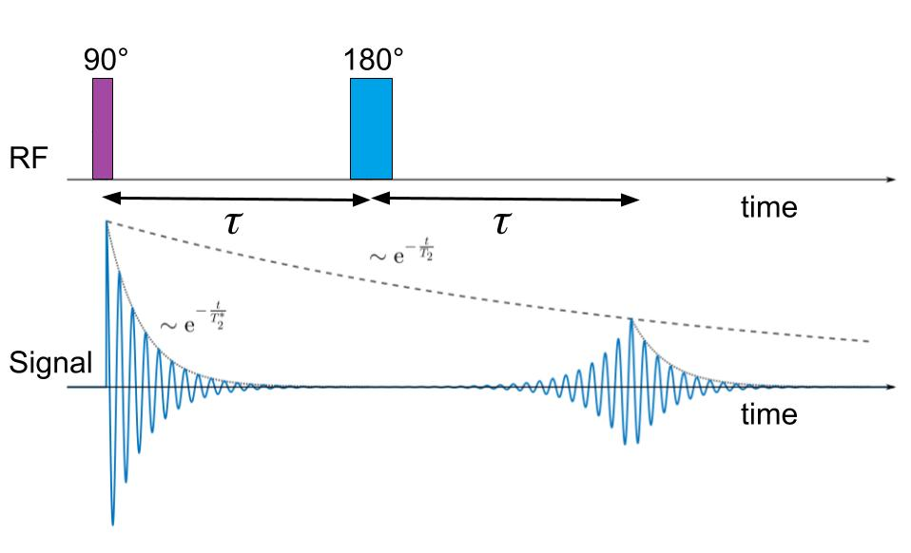

**coherence**- when the quantum states of the system stay correlated with each other; in quantum computing the coherence time relates to how long experimenters should expect the qubit to retain its current quantum state before it relaxes due to interactions with its environment

The traditional Hahn echo pulse sequence ( pulse followed by pulse) can refocus any dephasing along the transverse plane due to external magnetic field inhomogeneities because the pulse has the effect of flipping the spins with respect to the external magnetic field. Each individual spin is still precessing with the same frequency and direction as before, but effectively transplanted to a new spot on the Bloch sphere due to the pulse. They happen to be transplanted to the exact spot on the block sphere so that, as time goes on, they completely reverse whatever dephasing had previously occurred prior to the pulse. This appeared to be an apparent time reversal of what had been considered by everyone at the time an irreversible process! In the thermodynamics sense, whatever is mixed will not naturally become unmixed, even if you try to now mix it in the opposite direction. Hahn showed that there remained some *hidden order* in the MR signal (usually given the fancy name of **coherence**) that could be restored through the clever use of pulses.

**Check out a very informative Hahn echo animation** [https://en.wikipedia.org/wiki/Spin_echo#/media/File:HahnEcho_GWM.gif](https://en.wikipedia.org/wiki/Spin_echo%23/media/File:HahnEcho_GWM.gif%20)   
Gavin W Morley, [CC BY-SA 3.0](https://creativecommons.org/licenses/by-sa/3.0) via Wikipedia.

The Hahn echo provides a way to effectively get rid of the effect on the spins due to external magnetic field inhomogeneities - the primary cause of the short relaxation time constant. The Hahn echo will also refocus any dephasing caused by chemical shifts - the different local magnetic environments of the the targeted spins due to nearby electrons. However, since presumably *all* spins are being flipped by , this pulse will not impact the spin-spin interactions - since two magnets will still have the same interaction between them when you flip both of their orientations). The remaining decay of the Hahn echo signal must then be primarily due to spin-spin interactions.

**Check out an animation showing how the Hahn echo amplitude changes with increasing spacing between the two pulses** [https://commons.wikimedia.org/wiki/File:GWM_HahnEchoDecay.gif](https://commons.wikimedia.org/wiki/File:GWM_HahnEchoDecay.gif%20)   
Gavin W Morley, [CC BY-SA 3.0](https://creativecommons.org/licenses/by-sa/3.0) via Wikipedia.

## Guided Inquiry Questions

1. What relaxation time constant should the Hahn echo experiment enable you to measure?
2. Describe an experimental procedure that you could use to measure this relaxation time constant.

# Can We Find Using a Single Experiment and More Pulses?

Being able to measure the relaxation time is important for characterizing our NMR samples. For example, even if we are not directly detecting signal from impurities in water, measuring the relaxation time can quickly tell us if the water is pure, as the very rapidly decreases with even very low concentrations of impurities. Looking at the relaxation time can also help us better identify different tissues in MR images that otherwise look very similar using other forms of imaging.

Below is the multiple-pulse sequence developed by Carr, Purcell, Meiboom, and Gill (CPMG) that is the primary method of measuring the relaxation time.

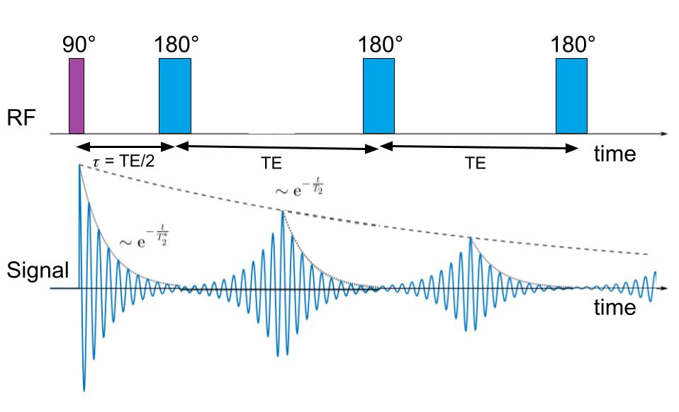

## Guided Inquiry Questions

1. How does the CPMG pulse sequence compare with the experimental procedure you developed in the previous question?
2. TE is the shorthand for the ‘echo time’ or the time spacing between consecutive 180 pulses. Why does it make sense that the time between the initial 90 pulse and the first 180 pulse is TE/2?
3. What are some advantages to using the CPMG pulse sequence instead of just the standard Hahn echo pulse sequence to measure ?
4. Describe how you would go about determining the relaxation time constant for a sample if given data from a CPMG experiment.

# Reflection Questions

1. Below is some H CPMG data collected using a heavy mineral oil sample and very short echo times (TE). Estimate the TE time that is being used to collect this data. What parameter, or , is being plotted along the y-axis? 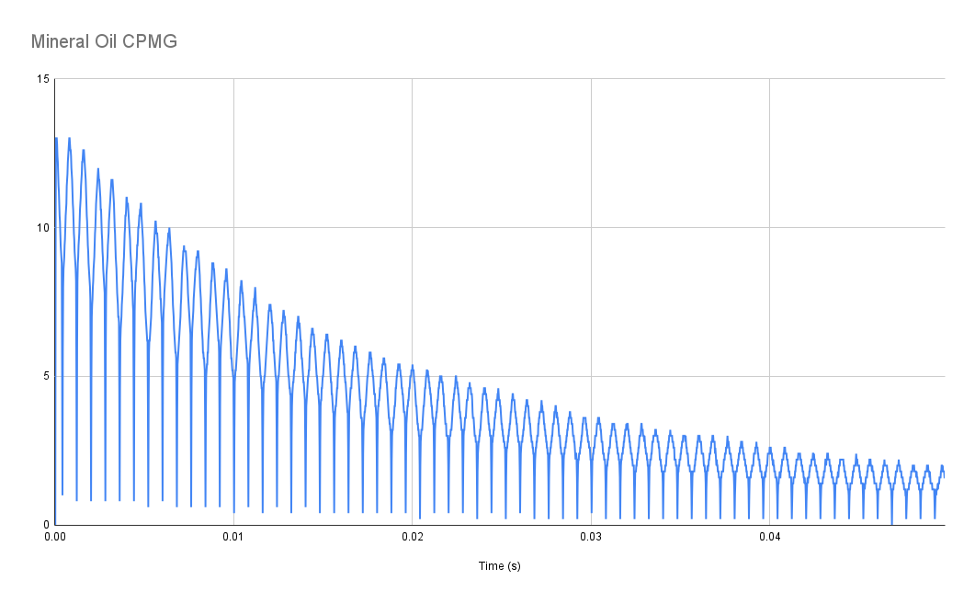
2. 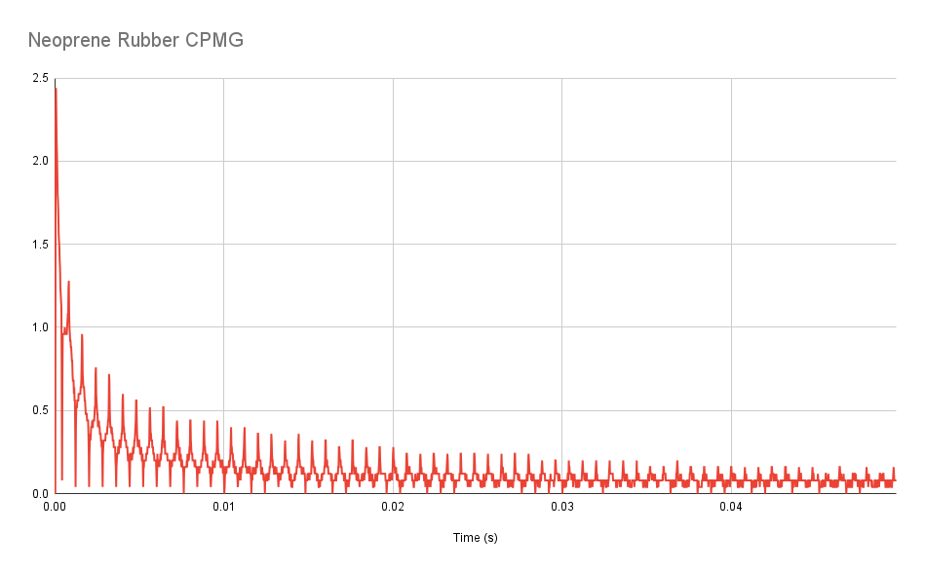Below is some H CPMG data collected from a neoprene rubber sample using the same experimental settings as for the mineral oil sample above. Estimate the relaxation time constant.

*RECALL:* The time constant for an exponential decay is the time it takes for an exponential function to reach ~ 0.37 (or 37%) of its initial (maximum) amplitude.

1. Comparing the time constants for the two samples above, what can you say about the local magnetic environment of neoprene rubber as compared with mineral oil (e.g., is it more or less homogeneous)?
2. Design an experiment that can test the hypothesis that the Hahn echo effectively gets rid of the effect of any external magnetic field inhomogeneities. Write a prediction of the results you would expect to see if you performed your experiment and this hypothesis was correct.

Below is a plot of the curves for brain tissue compared with water. You should use this plot to answer the following questions.

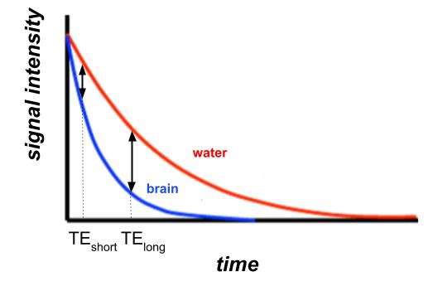

1. Which has the longer time, brain tissue or water?
2. You are designing a -weighted MRI pulse sequence that needs to highlight any water in the brain. Looking at the curves provided, which of the TE times (TE or TE) would be a better choice? Why?

**Challenge Questions**

Read about what Hahn referred to as the “eight-ball echo” at the following link: <https://www.mriquestions.com/90deg-90deg-hahn-echo.html>

Then answer the following challenge questions about the mysterious NMR signal below that was collected repeating an FID experiment with a short repetition (TR) time. 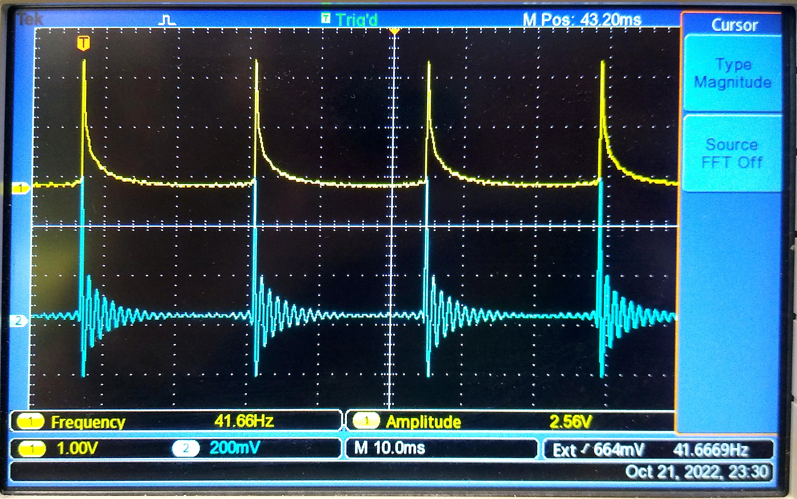

1. Using whichever representation or model you prefer, explain a possible source for the small signal we see right before each subsequent pulse. Why does it make sense that it appears to peak at the time the next pulse occurs?
2. Provide a pulse sequence and an experimental procedure to test your hypothesis for the source of the signal.

# Supplemental Reading

**Spin echoes:** <https://www.mriquestions.com/spin-echo1.html>

## Cited Sources

1. <https://royalsocietypublishing.org/doi/10.1098/rsbm.2019.0038> “Erwin Louis Hahn. 9 June 1921—20 September 2016”
2. <https://mri-q.com/uploads/3/4/5/7/34572113/hahn_spin_echo_paper_1950.pdf> “E. L. Hahn, Spin Echoes, Physical Review Vol.80, Number 4, pg.580, 1950.”